Rewiring for Lizzard Camera
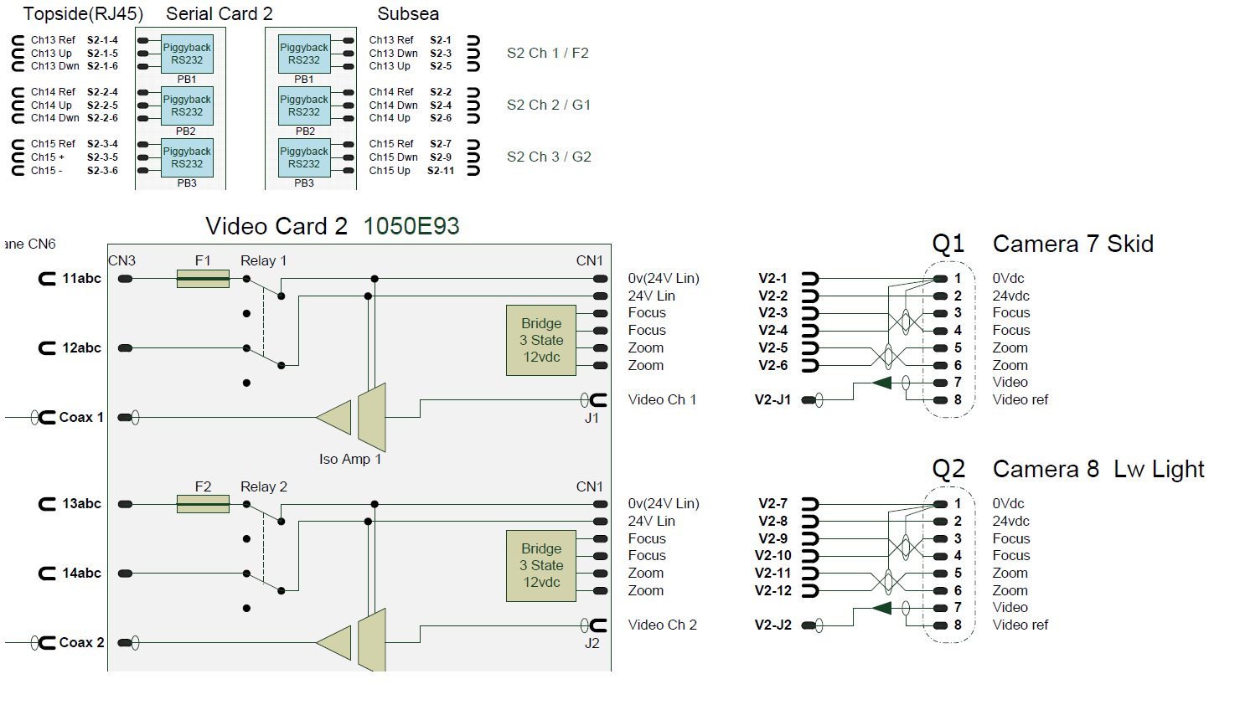

Camera is connected to Q2 for video and power but G2 also needs to be activated to get 232 comms.

V2-9 moved to S2-11
V2-10 moved to S2-9
V2-7 linked with S2-7 in a terminal block to get signal ref.

The conductors from S2-9 and S2-11 are isolated in a terminal block.

